**Question 1**

A circular queue is implemented using array of size 10. The array index starting with 0 , front is 4 and rare is 9. The insertion of next element takes place at which index of an array

1. 7
2. 9
3. 10
4. zero(0)

**Question 2**

what is the postfix expression of following infix expression  
  
**b*c+d/e*f**

1. bcdef**/+
2. bc*def*/+
3. bc*de/f*
4. bc*def/*+

**Question 3**

The infix expression is **A/B^C*D-E**

Select the correct option.

1. ABCD^*/E-
2. ABC^D/*E-
3. ABC^D*/E-
4. ABC^*/DE-

**Question 4**

In which expression the operator comes after the operant.

1. Postfix
2. Prefix
3. Infix
4. None of them

**Question 5**

What is a time complexity to convert an infix expression into a postfix expression.

1. O(n^2)
2. O(M log N)
3. O(n)
4. O(N log N)

From the given expression tree, identify the postfix expression.  
  
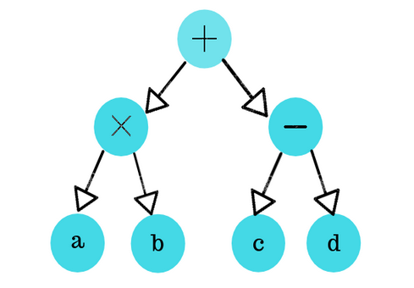

1. ab*cd*+
2. ab*cd-+
3. abcd-*+
4. ab*+cd-

**Question 7**

The postfix form of the expression (A*B)+(C/D)?

1. *AB/cd+
2. AB*CD/+
3. A*BC+/D
4. ABCD+/*

**Question 8**

Which data structure is needed in conversion of infix expression into a postfix expression.

1. Stack
2. Linked list
3. Queue
4. Tree

**Question 9**

What is the result of following operation:-  
  
Top(Push(S,A))

1. S
2. A
3. NULL
4. NONE OF ABOVE

**Question 10**

What will come after evaluate following expression.  
  
**5,4,6,+,*,4,9,3,/,+,\***\

1. 350
2. 400
3. 450
4. 500

ANSWERS  
  
Q1.A

**EXPLANATION:**  
  
The index of the circular queue from 0 to 9 and the queue fill till 9th index so that the next element is inserted from the index 0.  
Q2.A

Here we close the operant r in bracket according to operator priority  
  
**b*c+d/e*f**  
  
=b*c+d/(e*f)  
  
=b*c+((d/)ef*)  
  
=b*c+(def*/)  
  
=(b*c)+(def*/)  
  
=((bc*)+(def*/))  
  
=bc*def*/+  
Q3.A

**A/B^C*D-E**  
  
=A/(B^C)*D-E  
  
=A/((BC^)*D)-E  
  
=(A/(BC^D*))-E  
  
=(ABC^D*/)-E  
  
=ABC^D*/E-

Q4.A

The expression where  operator comes after the operant is called the postfix expression

Q5.A

when we convert any expression into other expression so it takes O(n).

Show Graph

Q6.A

when we extract postfix expression from tree so it follow a sequence that is left right root

Show Graph

Q7.A

(A*B)+(C/D)  
  
=(A*B)+(CD/)  
  
=(AB*)+(CD/)  
  
=AB*CD/+  
Q8.A

All the expression that is infix, postfix and prefix use stack.  
Q9.A

the expression Top(Push(S,A)) indicates that the element A push on the top of the stack  
  
   
Q10.A

**5,4,6,+,*,4,9,3,/,+,\***  
  
=5,(4,6,+),*,4,9,3,/,+,*  
  
=(5,10,*),4,9,3,/,+,*  
  
=50,4,(9,3,/),+,*  
  
=50,4,3,+,*  
  
=50,(4,3,+),*  
  
=50,7,*  
  
=350